Jump to: Step-by-Step About this topic Tips Related Topics

# Step-by-Step

1. Using the Navigation Panel on the left side of the screen, select the Department.

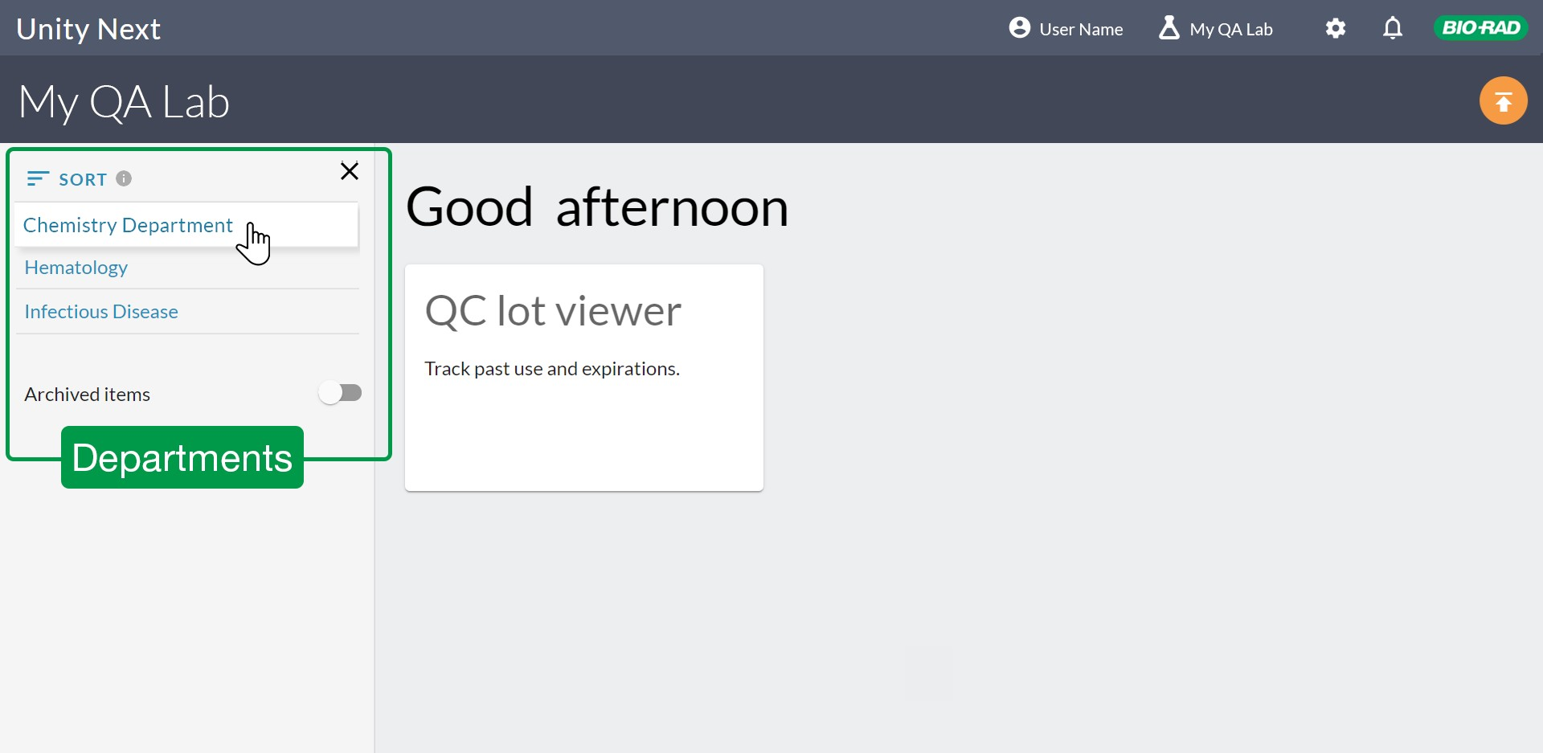

1. Select the Instrument.

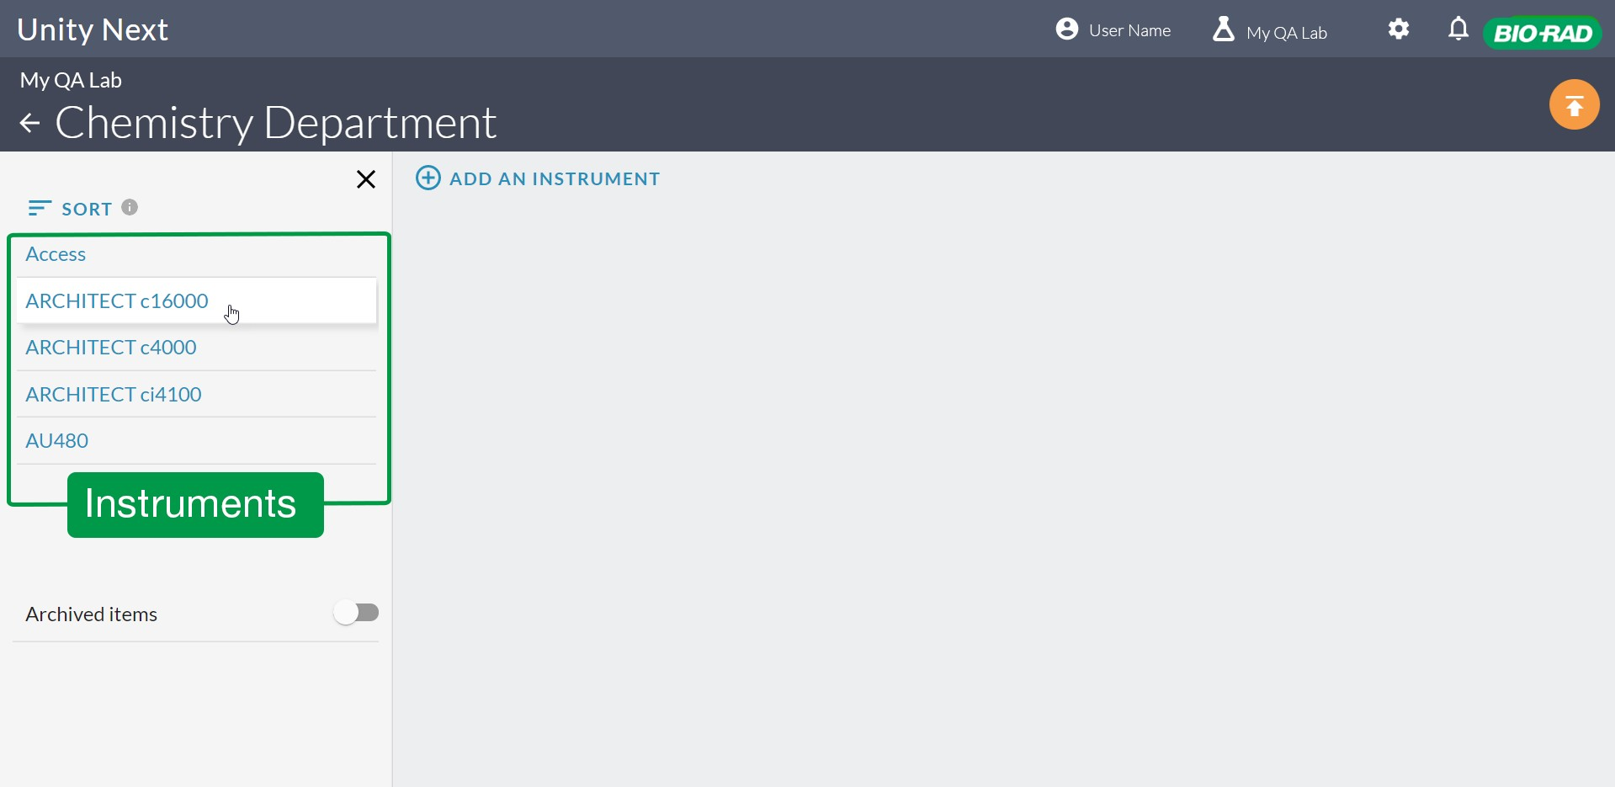

1. Select the Control Name.

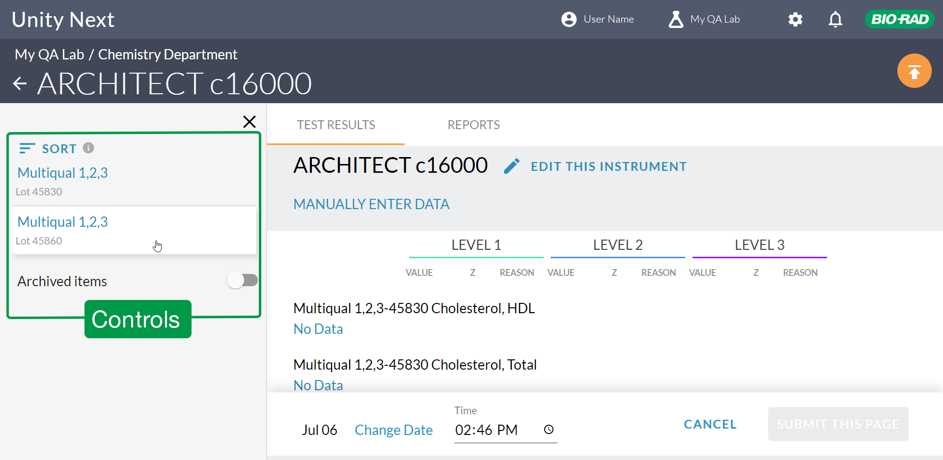

1. Select **Manually Enter Data.**

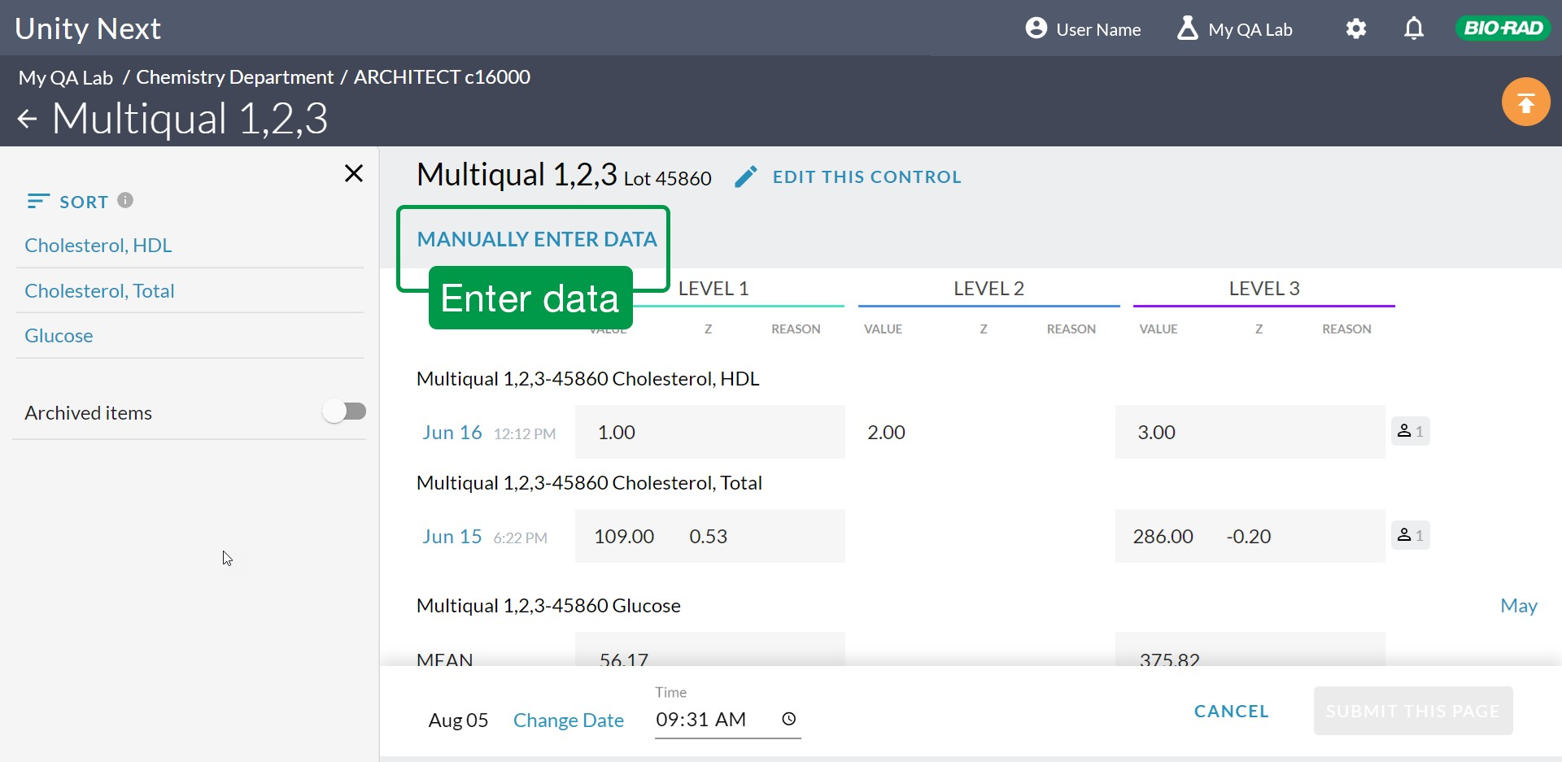

1. 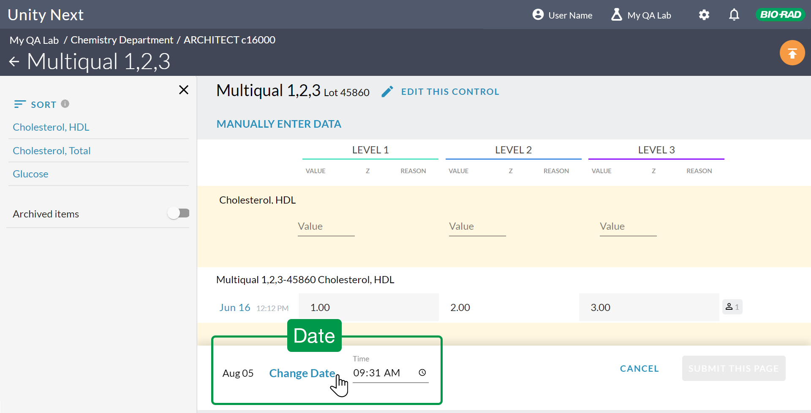Default is the current date. Or, click **Change Date** at the bottom of the screen and then select the date the QC was run.

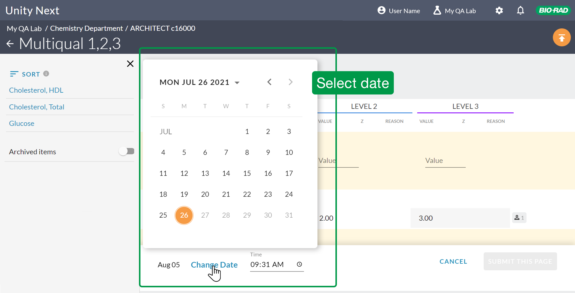

1. Enter the time at which you ran the data.

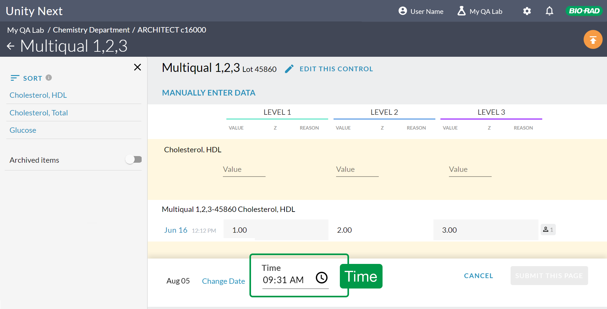

1. Enter the values for each level.

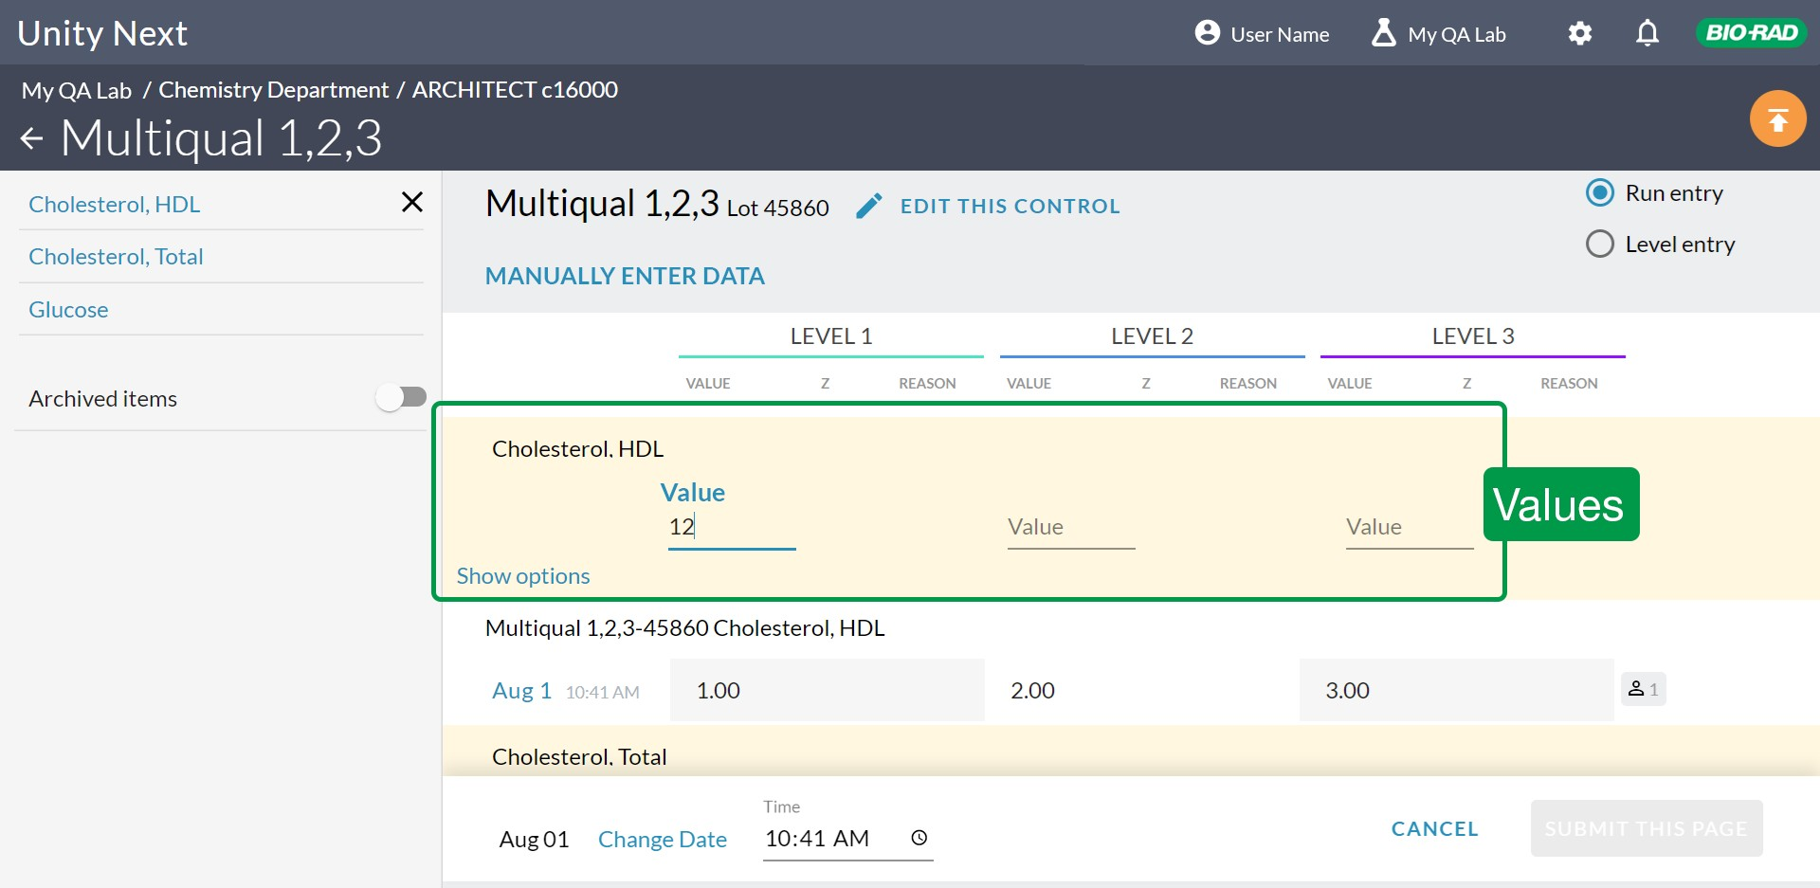

1. Select **SUBMIT THIS PAGE**.

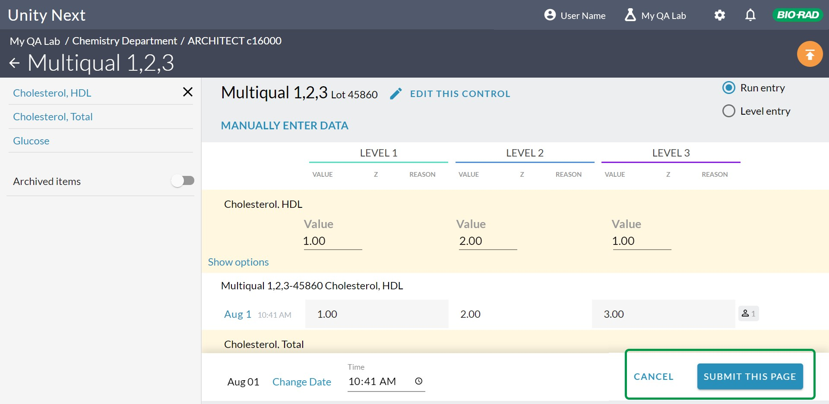

# About entering data for multiple analytes

Click **EDIT THIS CONTROL** to choose **Summary** or **Point** for **Type of data entry**.

The same setting will appear at the Analyte level, but if data is already entered, the existing **Type of data** entry will be the only way to enter data. The radio buttons will be greyed out.

Data entry can be selected at the analyte level. If data is already input for the lot as Point, you will not be able to enter Summary data for that analyte while editing data at the Control level screen. At the Control level, you will see the first line of existing point data for an analyte or the Summary data, depending on the Data entry type selected at the Analyte level.

Tips

Data entry type is re-set when you start a new lot.

·

· test

·

·

·

·

Enter summary data

Enter point data for single

Edit summary data Westgard Rules Delete a row of data

About floating statistics

**Related Topics**